  - Importer MDR Updating and creation
Reason: For Each site like Reynosa, Waltham etc importer MDRs is submitted on periodically basis
for that to happen, the Site’s details must be correct and present in the Windchill NA Server.
If not, we follow this documentation to create/update that detail.
Resembling ticket -
Title
Importer MDR UFI number and importer address update required.
Description
Importer MDR UFI number and importer address update required.
We need to submit Importer MDRs for Waltham Site
Site: Waltham
Registration Number: 1225714
Alt ID: WALTHAM
Address: Fresenius Medical Care North America
Address (line 1): Director, PV and PMS NA
Address (line 2): 920 Winter Street
City: Waltham
State: Massachussetts
Postal Code: 02451
Country: United States

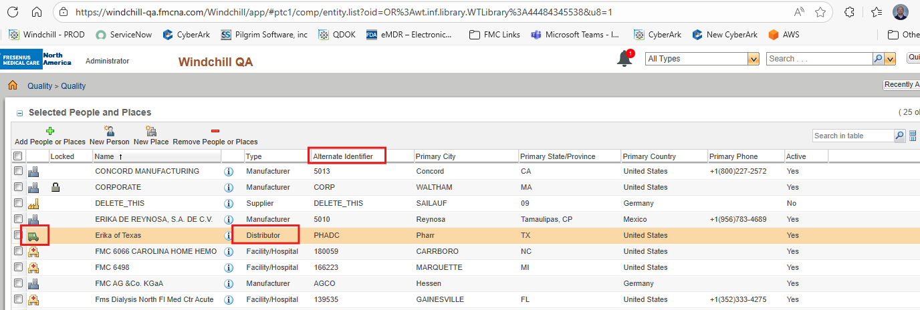
Solution-
Procedure: Adding a Distributor for eMDR Submissions
Environment: Windchill NA QA/Prod
1. Preparation & Environment Check
Before making any changes, ensures you are logged into the Windchill NA QA environment. Do not perform these steps in Production until the data has been verified.
2. Locating the People and Places Utility
- Navigate to the Quality tab.
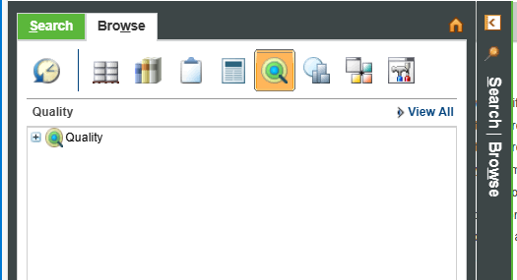
- Select the Quality sub-menu.
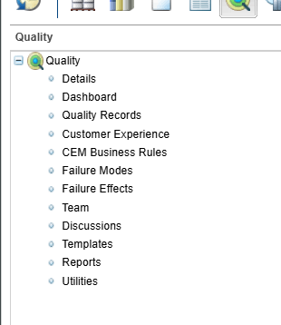
- Click on Utilities.
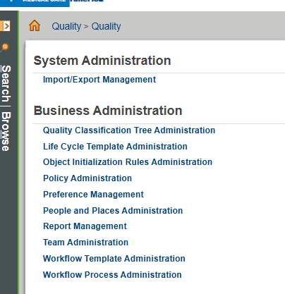
- Select People and Places Administration.

3. Verification of Existing Entries
To avoid duplicate data, you must search for the entity before creating a new one:
- Click on Add People or Places.
- Search for the entity using the Alternate ID (refer to the specific ticket for the ID number).
- If it exists: Verify the details match the ticket requirements.
- If it does not exist: Proceed to step 4.

4. Creating a New Entry
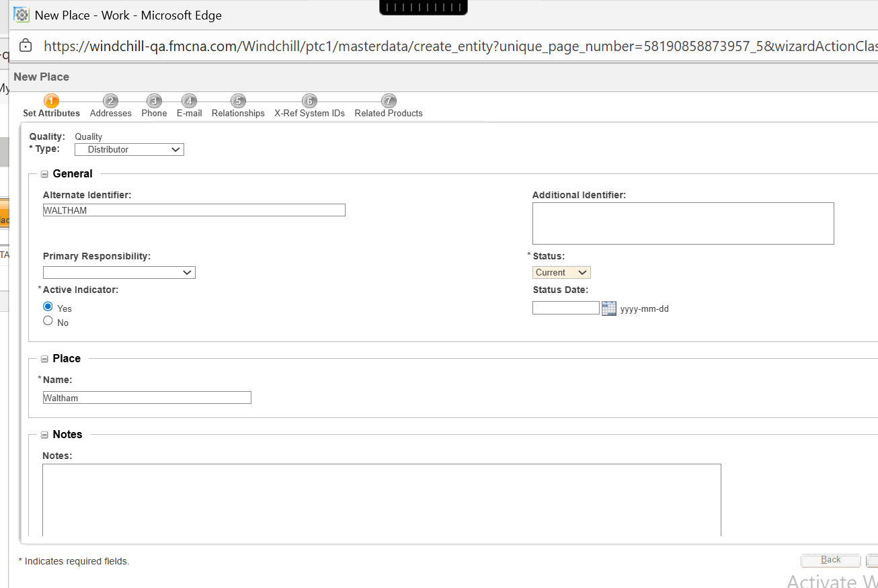
If the search yields no results, create the entry with the following parameters:
- Type: Described in request
- Identification: Ensure the name and Alternate ID are entered exactly as specified in the request.
5. Post-Setup Verification
Once the entry is created in the QA environment:
- Notify the team for data verification.
- Do not move to Production until FMC has confirmed that all data for the eMDR submission process is correct.

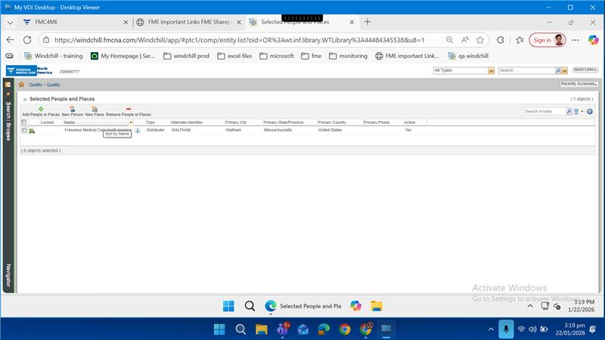
Best Practices for this Process
Note: Always double-check the "Alternate ID" field. This is the primary reference key used to sync these entries with the eMDR submission logic.

